My favourite Goalkeeper.
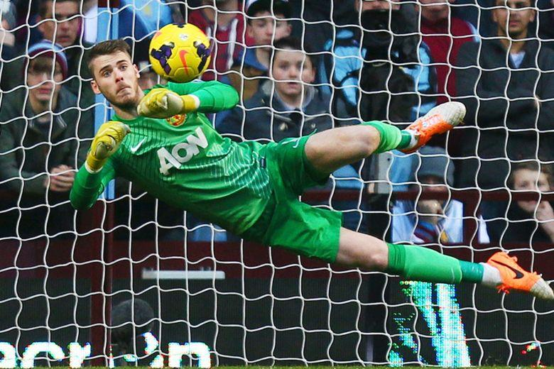
- David de Gea.
- He is from Spain.
- Goalkeeper for Manchester united & Spain.
- Born in Madrid 7th November 1990.
- He is one of the world’s best goalkeepers.
- He is 6ft 4in tall.
- His shirt number is number 1.
- He joined Atletico Madrid aged 13.
